Coordinated Danube Action for the titanic endeavor of tackling hazardous substances water pollution under changing pressures, challenges and targets Tethys

Workshop on sampling strategy and sample preparation procedures

27 and 28 May 2024, Ljubljana, Slovenia

Location:

Jožef Stefan Institute

Jamova 39, 1000 Ljubljana, Slovenia, Big lecture room

Physical or Hybrid meeting

https://zoom.us/j/91666575327?pwd=KzcySG9mcFh6TUdabzRKWENwUGpwUT09
Meeting ID: 916 6657 5327
Passcode: 766253

Agenda

Day 1: Monday, 27 May, 2024
8:45 | 9:00 | Welcome and opening the workshop (Radmila Milačič, JSI)
9:00 | 9:30 | Objective of monitoring of hazardous substances in support of MoRE emission model validation (Zsolt Jolánkai, Máté Kardos, BME)
9:30 | 9:50 | Discussion
9:50 | 10:20 | Standard operating procedures (SOPs) for monitoring of metals in river water, wastewaters, urban and runoff samples (Radmila Milačič, JSI)
10:20 | 10:40 | Discussion
10:40 | 10:55 | Coffee break
10:55 | 11:25 | Sampling and Standard operating procedures (SOPs) for monitoring of PFAS and pharmaceuticals metals in river water, wastewaters and urban runoff samples (Meiqi Liu, TU Wien)
11:25 | 11:45 | Discussion
11:45 | 12:45 | Lunch break
12:45 | 13:15 | Technical aspects of sample transport, sample labelling and bottles delivery (Radmila Milačič, JSI, Meiqi Liu, TU Wien)
13:15 | 13:30 | Discussion
Partners presentations of sampling sites
13:30 | 14:00 | Center for Ecotoxicological Research Podgorica – CETI, Crna Gora
14:00 | 14:15 | Discussion
14:15 | 14:45 | Ukrainian Hydrometeorological Institute State Service on Emergencies and National Academy of Science – UHMI, Україна
14:45 | 15:00 | Discussion
15:00 | 15:15 | Coffee break
15:15 | 15:45 | Public Institution “Vode Srpske” – JUVS, Public Institution “Vode Srpske”, Bosna i Hercegovina
15:45 | 16:00 | Discussion
16:00 | 16:20 | TU Wien, Österreich
16:20 | 16:30 | Discussion
Day 1: Monday, 27 May, 2024
16:30 | 17:15 | Visit to the laboratories of the Department of Environmental Sciences
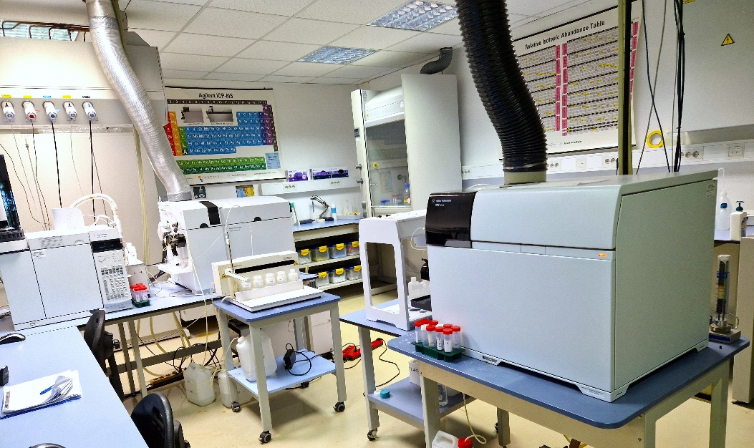
17:15 | 18:15 | Visit to the Ljubljana Castle
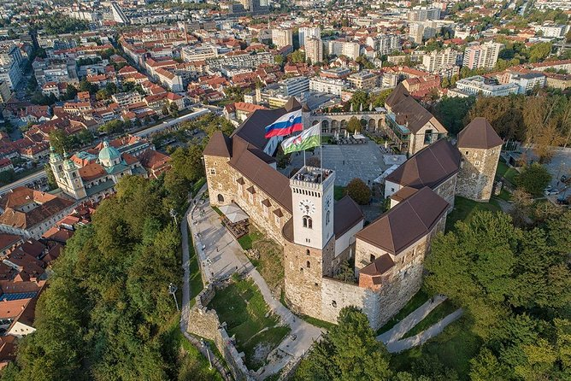
18:30 | 20:30 | Dinner organised by JSI
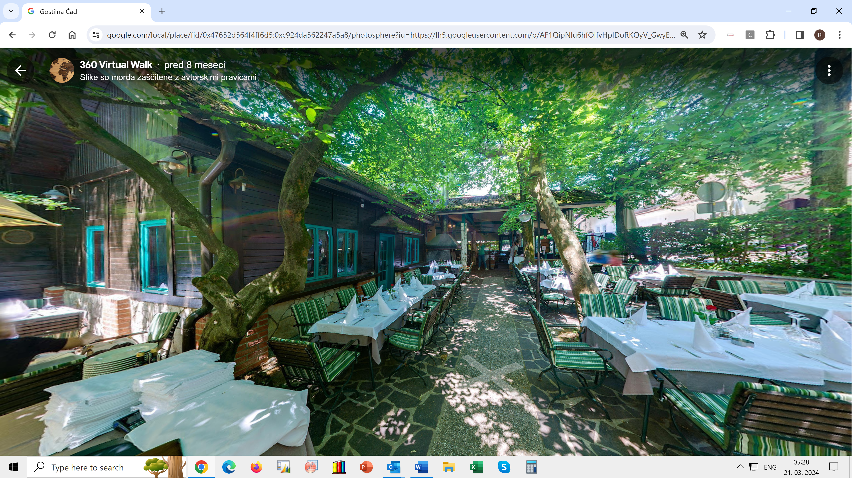
Day 2: Tuesday, 28 May, 2024 – Partners presentations of sampling sites
9:00 | 9:30 | Jaroslav Černi Water Institute – JCWI, Србија
9:30 | 9:45 | Discussion
9:45 | 10:05 | Budapest University of Technology and Economics – BME, Magyarország
10:05 | 10:15 | Discussion
10:15 | 10:35 | Bulgarian Water Association – BWA, България
10:35 | 10:45 | Discussion
10:45 | 11:05 | National Administration „Romanian Waters” – NARW, România
11:05 | 11:15 | Discussion
11:15 | 11:30 | Coffee break
11:30 | 11:50 | Water Research Institute – WRI, Slovensko
11:50 | 12:00 | Discussion
12:00 | 12:20 | Croatian Waters – HV, Hrvatska
12:20 | 12:30 | Discussion
12:30 | 12:50 | Jožef Stefan Institute – JSI, Slovenija
12:50 | 13:00 | Discussion
13:00 | 13:15 | Conclusions – Actions needed (Radmila Milačič, JSI)
13:15 | 14:15 | Lunch
Welcome!
Jožef Stefan Institute, Jamova cesta 39, 1000 Ljubljana

